Burundi

## Political Stability Estimate Data

The data set shows the political stability estimate of the country each year.

## # A tibble: 19 x 5  
## country iso3c date stability stabilityCategory4   
## <chr> <chr> <dbl> <dbl> <chr>   
## 1 Burundi BDI 1996 -2.11 highly unstable   
## 2 Burundi BDI 1998 -2.29 highly unstable   
## 3 Burundi BDI 2000 -2.02 highly unstable   
## 4 Burundi BDI 2002 -2.29 highly unstable   
## 5 Burundi BDI 2003 -2.24 highly unstable   
## 6 Burundi BDI 2004 -2.52 highly unstable   
## 7 Burundi BDI 2005 -1.52 highly unstable   
## 8 Burundi BDI 2006 -1.43 highly unstable   
## 9 Burundi BDI 2007 -1.38 highly unstable   
## 10 Burundi BDI 2008 -1.64 highly unstable   
## 11 Burundi BDI 2009 -1.27 highly unstable   
## 12 Burundi BDI 2010 -1.63 highly unstable   
## 13 Burundi BDI 2011 -1.81 highly unstable   
## 14 Burundi BDI 2012 -1.70 highly unstable   
## 15 Burundi BDI 2013 -1.35 highly unstable   
## 16 Burundi BDI 2014 -0.784 moderately unstable  
## 17 Burundi BDI 2015 -1.94 highly unstable   
## 18 Burundi BDI 2016 -1.97 highly unstable   
## 19 Burundi BDI 2017 -1.97 highly unstable

## Political Stability Estimate Plot

The plot shows the trends of stabilization and destabilization for the each country.

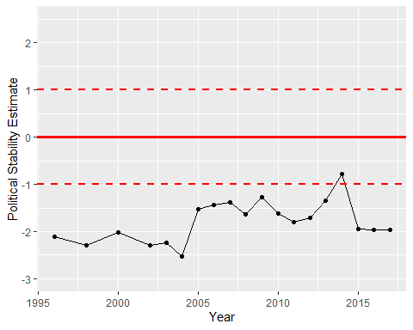

Political Stability Trend